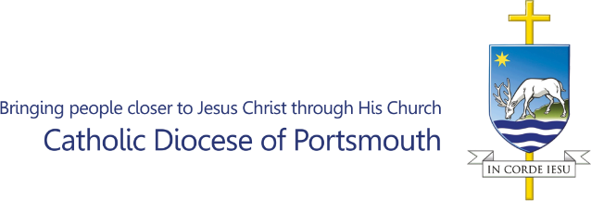

**Guide for Parish Safeguarding Ministers (PSM) / Identity (ID) Verifiers – processing DBS applications.**

Please note all those working with children and/or adults at risk or those who are otherwise vulnerable within your parishes must be safely recruited. Volunteer registration forms and references must be obtained and progression with appointment confirmed, prior to requesting a DBS check.

It is the responsibility of the parish to complete this part of the recruitment process and retain the documents within the parish records.

**DBS application process.**

**1) New applicants undergoing a DBS check must:**

* Complete a volunteer registration form (progressed in parish by PSM/Group Leader and held within parish records).
* Complete a reference request form (references progressed in parish by PSM/Group Leader and held within parish records).
* Complete a DBS 3C confirmation of identity form and declaration.
* Supply three documents to PSM/ID verifier for verification (in accordance with 3C guidance notes).

A link to the electronic DBS application form will then be sent to applicant via email after the above forms and documents are received by the central safeguarding team.

**2) Applicants undergoing a 3-year recheck who are NOT subscribed to the online update service must:**

* Complete a DBS 3C confirmation of identity form and declaration.
* Supply three documents to PSM/ID verifier for verification (in accordance with 3C guidance notes).

A link to the electronic DBS application form will then be sent to the applicant via email, after the above forms and documents are received by the central safeguarding team.

**3) Applicants undergoing a 3-year recheck who ARE subscribed to the DBS online update subscription service, with a certificate issued via the Diocese of Portsmouth, who have not changed their role or added any new roles must:**

* Complete a DBS 4 safeguarding self-declaration form.

**4) Applicants applying for a DBS check who ARE subscribed to the DBS online update subscription service, AND are seeking to use a certificate issued via another diocese, religious order, organisation, or their employer, where the level of check issued on the original certificate is an identical level of check needed for their current role, must:**

* Complete a DBS4 safeguarding self-declaration form.
* Complete a DBS 13 (update service ID verification form).
* Supply three documents to PSM/ID verifier for verification (in accordance with 3C guidance notes).
* Present their original certificate for verification by the PSM/ID verifier (photocopies cannot be accepted).

If an applicant cannot provide their original certificate for verification, they will be required to undergo the process as per a new applicant at point 1) above.

If the level of check on the original certificate is different to that needed for the role being applied for, the applicant is required to undergo the process as per a new applicant at point 1) above.

**Submissions.**

All completed DBS forms and copies of ID documents should be scanned and sent to electronically to the central safeguarding team at: [safeguarding@portsmouthdiocese.org.uk](mailto:safeguarding@portsmouthdiocese.org.uk)

Copies of these do not need to be retained in parish records.

If you are unable to send paperwork electronically, the postal address is:

DBS Safeguarding Administration Team

St Edmunds House

Bishop Crispian Way

Portsmouth

PO1 3QA

Please note, there can be significant delay when sending documents by post.

Any postage costs incurred can be reclaimed via the parish office. Alternatively, documents can be sent using parish office resources.