**ST. VINCENT DE PAUL R.C. CHURCH**

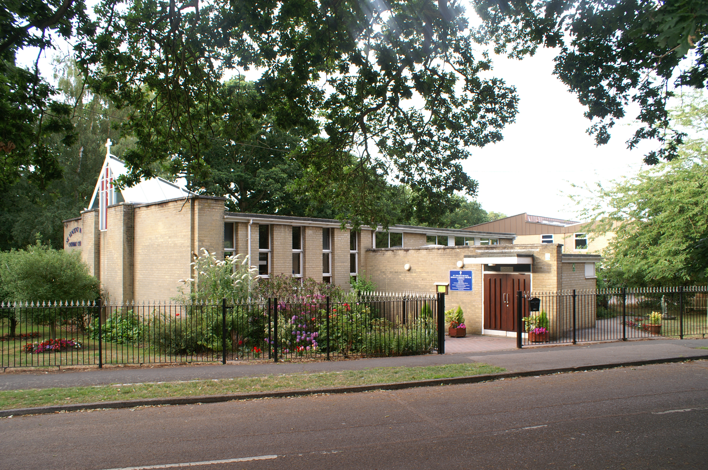

Aldermoor Close, off Coxford Road, Lordswood, Southampton, Hampshire. SO16 5ST

**Parish Priest:** Father Tomy Chirackalmanavalan

**Contact details:** email: fathertomy@portsmouthdiocese.org.uk Mobile: 07480 730503

**Retired Priest:** Father Michael Cronin Mobile: 07400262398 (1pm to 5pm)

**Office Administrator**: Renee Sharp email: svpoffice@portsmouthdiocese.org.uk

**Newsletter editor**: Malcolm Forster email: malcolmandrita@btinternet.com

21 Bassett Crescent West, Bassett, Southampton SO16 7EB

Tel: 023 80790942 Mobile: 07774 400115

**First Sunday of Lent Sunday 26th February 2023**

**Genesis 2: 7-9 to 3: 1-7 Romans 5: 12-19 Matthew 4: 1-11**

Lent is primarily the time of intense spiritual preparation for conquering our temptations, using the means Jesus used during his forty days of preparation in the desert for his public life. It is also the time for repenting of our sins and renewing our lives for the celebration of Easter with our Risen Lord who conquered sin and death by his suffering, death and Resurrection. Today’s readings teach us that we are always tempted by the devil, by the world, and by our own selfish interests. So, we need to cooperate actively with God’s grace to conquer our temptations and practice prayer, self-control, and charity. The first reading, taken from the book of Genesis describes the “Original Temptation” – “You will be like gods, knowing what is good and what is evil.” Adam and Eve were given the possibility of making a choice to live for God, dependent upon and obedient to His will, or to say no to God. The temptation to evil led Adam and Eve to an act of faithlessness and sin. In contrast, today’s Gospel from St. Matthew shows us how Jesus Christ conquered temptation by relying on Faith in God’s Word and authority. In the second reading, St. Paul describes how the disobedience of Adam, who fell to Satan’s Original Temptation, brought him and us sin, death, and a broken relationship with God. Paul explains that Christ regained for us a right relationship with God by his perfect obedience to God his Father. Today’s Gospel teaches us how the “desert experience” of fasting, praying, and soul-strengthening enabled Jesus to confront his temptations successfully and then to preach the Good News of salvation. The tempter urges Jesus to turn stones into loaves of bread. But Jesus rejects that temptation to mistrust His Father by satisfying his own immediate, temporal needs — thus reducing His Divine mission to self-satisfaction! The tempter then suggests that Jesus prove that he is really the Son of God by jumping off the parapet of the Temple. Jesus rejects this as a temptation to act as God’s superior and demand He prove His Trustworthiness! Finally, Jesus rejects the temptation to idolatry, even if worshipping Satan would enrich and empower Jesus with all kingdoms of the world.

Yours, Fr. Tomy

|  |  |
| --- | --- |
| **Mass times Feast Days** | |
| **6pm: Confessions**  **6.30pm Vigil Mass** | **Saturday 25th  St Walburga** Born 708 in Devon to St Richard the Pilgrim, the King of the West Saxons and her mother was St Wuna of Wessex, sister of St Boniface.. Walburga had brothers St Willibald and St Winibald. She was educated at Wimborne monastery in Dorset, and joined as a nun. Copied and decorated manuscripts and learnt fine needlework & embroidery. Missionary in Germany with her uncle St Boniface and her brothers. Skilled in medicine. Abbess of a double monastery. |
| **9.30 am** | **Sunday 26th February First Sunday of Lent**  ***Intention:* Michael Hunter R.I.P and Ian Hunter R.I.P. (recently died)** |
| **First Communion Training from 16:45 t0 17:45**  **6.30 pm** | **Monday 27th St Anne Line** Born about 1665. Father was a rich Calvinist and Protestant reformer. Anne and her brother became Catholics and were then disowned. She married Roger Line from the New Forest, also a convert.. Roger her husband was arrested and banished from England. After 10 years he died in Flanders in 1594. Anne was asked by Jesuit priest Fr John Gerard to look after a “safe house” in London. Forced to continually move to new premises. Eventually arrested, found guilty of hiding priests and organising Masses. Anne was executed in 1601. One of the 40 Martyrs. |
| **10 am** | **Tuesday 28th St Oswald of Worcester** Born in about 925 of Danish parents. Educated by his uncle Odo, later Archbishop of Canterbury, and a Frankish tutor. Oswald became Dean of Winchester. He became a Benedictine monk at Fleury-sur-Loire, France. He helped Danish relative Archbishop Oskytel of York. Appointed Bishop of Worcester. Founded monasteries. Invited Continental scholars to teach in them. As a bishop was a Church reformer. Then made Archbishop of York. |
| **6.30 pm** | **Wednesday 1st March St David of Wales** Born in about 500 during a storm, her mother a nun had been raped by a Prince. Was educated at a monastery by Abbot St Paulinus. A great preacher and teacher. Founded twelve monasteries including Glastonbury Abbey, on Caldey Island and in Mynyw in Pembrokeshire where he stayed. Led an austere life style. Only drank water and ate only bread, herbs and vegetables. Strict regime of religious activities and hard work in the fields, crafts and beekeeping. Bishop of Menevia in South Wales. His shrine in Wales was a place of pilgrimage. |
| **10 am** | **Thursday 2nd St Chad** Born about 634 in Northumbria, the youngest of 4 brothers who all became priests, two of them bishops. He was taught by Bishop Aidan at Lindisfarne off the north east coast of England. Became a monk in Ireland. Appointed Abbot of Lastingham by his brother Bishop Cedd. Then appointed Bishop of York by King Oswy in the absence of St Wilfred who had gone to France to be consecrated. Returned to Lasting when St Wilfred returned. Archbishop Theodore of Canterbury made him Bishop of Mercia. Made his centre Lichfield and converted many in the Midlands of England away from paganism including King Wulfere and his Queen. First Bishop of Lichfield. |
| **CAFOD Family Fast Day for Lent**  **Stations of the Cross at 6pm every Friday during Lent Except Good Friday**  **No Mass** | **Friday 3rd St Katharine Drexel** Born in 1858 in America, youngest of two sisters. Her mother died and her father remarried and had another daughter. A loving prayerful family who helped the poor. Tree girls promoted the rights of Native Indian Americans and Black Afro Americans. She was strongly opposed by the Ku Klux Klan. Set up schools and missions. Katherine founded the Order of Sisters of the Blessed Sacrament dedicated to working with the two ethnic groups in America. |
| **6pm: Confessions**  **6.30pm Vigil Mass** | .**Saturday 4th St Casmir of Poland** Born in 1458 at Wawel Castle, Kraków, Poland, second son of King Casmir IV of Poland. Prince Casmir was brought up by his loving mother and a priest. Was a prayerful youth who helped the poor. Involved in a war and had to lead an army aged only 13. Made peace much to his father’s annoyance. Vowed never to take up arms again. Pleaded with his father to act more justly. Gave his wealth to the poor. Refused marriage. Austere and holy life. Died at 29. |
| **9.30 am** | **Sunday 5th March Second Sunday of Lent**  ***Intention:* Valentine – for Mercy** |
| **PLEASE PRINT IN BLOCK CAPITALS WHEN RECORDING NAMES FOR MASS INTENTION** | |

|  |  |  |  |
| --- | --- | --- | --- |
| **Your prayers are needed for the following people** | | | |
| Diana Stimson | Sue Chandler | Hazel Sale | Joe Heatley |
| Kay Duggan |  |  |  |

**NOTICES AND ANNOUNCEMENTS**

**PLEASE NOTE** – due to the amount of space and print that Diocesan job vacancies take up, I have copied current vacancies and made a space for them on the noticeboard to your left as you enter the Church. Alternatively you can get details from recruitment@portsmouthdiocese.org.uk Renee

**CAFOD Family Fast Day for Lent is on Friday 3rd March – Collection next weekend**

This is an opportunity during Lent to eat simply, to pray and to donate to CAFOD so that they can give support to people in places such as Bangladesh who are suffering cyclones and floods due to the climate crisis which have destroyed their crops. Farming tools and training are given to them. CAFOD also helps communities suffering extreme hunger due to the impact of war and droughts. Please be generous.

**Next Social on a Wednesday 1st March – 1 to 3 pm**

There will another opportunity to meet for refreshments and a chat. Please come along and bring your friends. No need to stay for the whole time, a few minutes of two hours, whatever suits you. Look forward to welcoming you. Renee and Pat.

**8 hours of adoration followed by Mass every month from 9 pm**

On the third Friday of each month, we are having 8 hours of adoration starting at 9 pm and ending with Mass at about 4 am. The next session will be Friday 17th March from 9 pm to 5 am

|  |  |
| --- | --- |
| **Parish collection for last Sunday 19th February** | **SPECIAL COLLECTION** |

|  |  |  |  |  |  |  |  |  |  |  |  |  |  |  |  |
| --- | --- | --- | --- | --- | --- | --- | --- | --- | --- | --- | --- | --- | --- | --- | --- |
| **Envelopes**  **Including Gift Aid** | | **Loose plate** | | **Monthly direct debits,**  **standing orders &**  **bank transfers**  **including Gift Aid** | | **Without Gift Aid** | | **TOTAL**  **TO**  **PARISH** | | **N/A** | | **N/A** | | **TOTAL**  **Including any**  **SPECIAL COLLECTIONS** | |
| £80.00 | | £194.84 | | £300.23 | | £68.13 | | **£643.20** | | 0 | | 0 | | **£643.20** | |

**Family Retreat being organised by Catholic Mothers of Southampton** **on Saturday 11th March**

A Catholic Family Day of Reflection is being organised by Miriam Ludgate of the Catholic Mothers of Southampton on Saturday 11th March at St Dominic’s Priory in Sway, New Forest from 10am to 2pm

This day is aimed at families with children up to the age of 7.  Suggested donation £20

For more information or to book a space for your family, email catholicmotherssoton@gmail.com