**ST. VINCENT DE PAUL R.C. CHURCH**

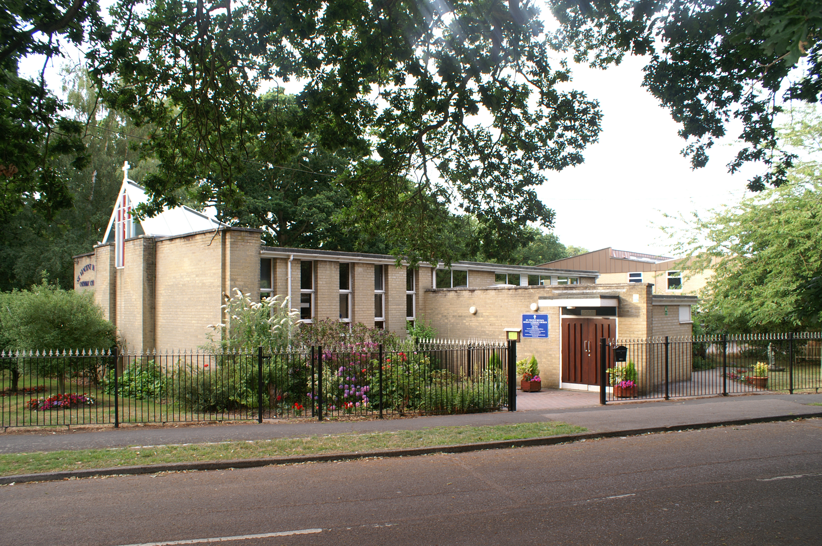

Aldermoor Close, off Coxford Road, Lordswood, Southampton, Hampshire. SO16 5ST

**Parish Priest:** Father Tomy Chirackalmanavalan

**Contact details:** email: fathertomy@portsmouthdiocese.org.uk Mobile: 07480 730503

**Retired Priest:** Father Michael Cronin Mobile: 07400262398 (1pm to 5pm)

**Office Administrator**: Renee Sharp email: svpoffice@portsmouthdiocese.org.uk

**Newsletter editor**: Malcolm Forster email: malcolmandrita@btinternet.com

21 Bassett Crescent West, Bassett, Southampton SO16 7EB

Tel: 023 80790942 Mobile: 07774 400115

**Second Sunday of Lent Sunday 5th March 2023**

**Genesis 12: 1-4 2 Timothy 1: 8-10 Matthew 17: 1-9**

The common theme of today’s readings is metamorphosis or transformation. The readings invite us to work, with the assistance of the Holy Spirit, to transform and renew our lives during Lent, that we may radiate the glory and grace of the transfigured Lord which we have received, to all around us by our Spirit-filled lives. The first reading describes the transformation of a pagan patriarch into a believer in the one God. His name will be transformed from Abram to Abraham and his small family into a great nation. All Abram has to do is to obey the Lord God’s command, and he does so. The second reading, taken from St. Paul’s second letter to Timothy, explains the type of Lenten transformation expected of us. We are transformed when we recognize the hand of a loving, providing, and disciplining God behind all our hardships, pain, and suffering and try our best to grow in holiness by cooperating with the grace of God given to us through Jesus and his Gospel. In the Transfiguration story in today’s Gospel, Jesus is revealed as a glorious figure, superior to Moses and Elijah. The primary purpose of Jesus’ Transfiguration was to allow Jesus to consult his Heavenly Father in order to ascertain His plan for His Son’s suffering, death and Resurrection. The secondary aim was to make his chosen disciples aware of Jesus’ Divine glory, so that they might discard their worldly ambitions and dreams of a conquering political Messiah and might be strengthened in their time of trial. On the mountain, Jesus is identified by the Heavenly Voice as the Son of God. Thus, the Transfiguration narrative is a Christophany, that is, a manifestation or revelation of who Jesus really is. Describing Jesus’ Transfiguration, the Gospel gives us a glimpse of the Heavenly glory awaiting those who do God’s will by putting their trusting Faith in Him, as the Responsorial Psalm (Ps 33), for today encourages us to do.

Yours

Fr. Tomy

|  |  |
| --- | --- |
| **Mass times Feast Days** | |
| **6pm: Confessions**  **6.30pm Vigil Mass** | **Saturday 4th St Casmir of Poland** Born in 1458 at Wawel Castle, Kraków, Poland, second son of King Casmir IV of Poland. Prince Casmir was brought up by his loving mother and a priest. Was a prayerful youth who helped the poor. Involved in a war and had to lead an army aged only 13. Made peace much to his father’s annoyance. Vowed never to take up arms again. Pleaded with his father to act more justly. Gave his wealth to the poor. Refused marriage. Austere and holy life. Died at 29. |
| **9.30 am** | **Sunday 5th March Second Sunday of Lent**  **Valentine – for Mercy** |
| **First Communion Training from 16:45 t0 17:45**  **6.30 pm** | **Monday 6th St Colette of Corbie** Born in 1381 in France. Carpenter’s daughter. Orphaned aged 17. Tried being a lay religious in two Orders. Then became a Franciscan hermit aged 21. For 4 years.. Had visions of St Francis of Assisi to make the *Poor Clares* observe stricter rules of austerity. Antipope Benedict XIII gave her powers to reform the *Poor Clares.* Colette met a lot of opposition. Eventually started new convents with rule of absolute poverty and went barefoot. Rules of fasting and abstinence . 18 convents in her lifetime with nuns that were known as *Colettine Sisters.* |
| **10 am** | **Tuesday 7th St Perpetua and St Felicity** Two black saints born in North Africa, now Tunisia, at the end of the second century. Perpetua was of noble birth and had a young baby. Felicity was a pregnant slave girl. With others they were arrested in Carthage, North Africa for wanting to be Christians in 203. They were baptised in prison. Faced a trail and condemned to be thrown to the wild beasts in the Coliseum in Carthage. Both died by the sword as martyrs with their companions. |
| **6.30 pm** | **Wednesday 8th St John of God** Born 1495 in Portugal. Left home. Travelled with a priest to Spain. Worked as a shepherd. Joined the Spanish army to fight the French. Then fought the Islamic Ottoman Turks in Europe for 18 years. Had a distinguished military career. Went to Africa to release Christians from the Islamic Moors. Returned to Spain. Met John of Avila who encouraged him to work with the poor. He had visions of the infant Jesus and Virgin Mary. Opened a hospital, night shelter for the homeless & a refuge for prostitutes. Founded an Order of Brother Hospitallers of St John of God. |
| **10 am** | **Thursday 9th St Frances of Rome** Born in 1384 in Rome to wealthy parents. Wanted to be a nun. Forced into an arranged marriage at age 13 to noble soldier and socialite. Initially unhappy but settled down to a happy marriage with 3 children. Did works of charity with her sister-in-law Vannozza, her spiritual friend. The flood in Rome brought disease and famine. Frances organised help Great Schism occurred between the pope and two antipopes. Civil War broke out in Rome. The children of Frances were under threat. Her husband was then wounded and their palace home wrecked. But despite this what was left was used as a hospital. The plague in Rome killed her son. Her daughter and husband died. Frances founded Oblates of Mary for lay women following the Rule of St Benedict. |
| **No Mass**  **6pm Stations of the Cross** | **Friday 10th St John Ogilvie** Born in 1579 in Scotland, son of a Calvinist baron. Sent to the Continent for education. Became a Catholic and Jesuit and ordained priest. Was sent to Scotland to minister to the remaining Catholics.. Arrested, tortured and accused of treason. His humour, wit and courage impressed his persecutors and softened his treatment. Sent to trail and found guilty. John was executed as a martyr in Glasgow on 10th March 1615. He was canonised by Pope Paul VI in 1976. |
| **10 am to 2 pm Catholic Family Day of Reflection at St Dominic’s Priory, Sway**  **6pm: Confessions**  **6.30pm Vigil Mass** | **Saturday 11th St Maximilian of Tebessa** Born about 274 in Tebessa, part of present day Algeria. His father, a Christian named Fabius Victor, was formally a soldier in the Roman army. The area of North Africa had been controlled by Rome for four centuries. In 295, a Roman proconsul sailed to North Africa to recruit soldiers for the Third Augustine Legion stationed in the area. Most were volunteers , but there was an obligation of service for sons of veterans. Maximilian was recruited for the Roman army when he was 21 years old and a Christian. He was tall and physically very strong and ideal for the army but was a “conscience objector and refused to fight. He also refused to offer sacrifices to pagan gods and would not swear allegiance to the Roman Emperor saying, “I will not be a soldier of this Roman army. I am a soldier of Christ and will only fight for Him. |
| **9.30 am** | **Sunday 12th March Third Sunday of Lent**  Nikki Okonicwd |
| **PLEASE PRINT IN BLOCK CAPITALS WHEN RECORDING NAMES FOR MASS INTENTION** | |

|  |  |  |  |  |  |
| --- | --- | --- | --- | --- | --- |
| **Your prayers are needed for the following people** | | | | | |
| Diana Stimson | Sue Chandler | Hazel Sale | Joe Heatley | Kay Duggan |  |

**NOTICES AND ANNOUNCEMENTS**

**Special Collection this weekend after CAFOD Family Fast Day for Lent last Friday 3rd March**

Please be as generous as possible so that CAFOD can give help and support to areas of the world suffering floods and cyclones that destroy their crops and other parts that have experienced extreme hunger caused by the impact of war and droughts. Campaign is “Growing in Strength, rooted in Love”.

**Family Retreat being organised by Catholic Mothers of Southampton** **on Saturday 11th March**

A Catholic Family Day of Reflection is being organised by Miriam Ludgate of the Catholic Mothers of Southampton on Saturday 11th March at St Dominic’s Priory in Sway, New Forest from 10am to 2pm

This day is aimed at families with children up to the age of 7.  Suggested donation £20

For more information or to book a space for your family, email catholicmotherssoton@gmail.com

**Next monthly Social on a Wednesday 15th March – 1 to 3 pm**

There will another opportunity to meet for refreshments and a chat. Please come along and bring your friends. No need to stay for the whole time, a few minutes of two hours, whatever suits you. Look forward to welcoming you. Renee and Pat.

**8 hours of adoration followed by Mass every month from 9 pm**

On the third Friday of each month, we are having 8 hours of adoration starting at 9 pm and ending with Mass at about 4 am. The next session will be Friday 17th March from 9 pm to 5 am

|  |  |
| --- | --- |
| **Parish collection for last Sunday 26th February** | **SPECIAL COLLECTION** |

|  |  |  |  |  |  |  |  |  |  |  |  |  |  |  |  |
| --- | --- | --- | --- | --- | --- | --- | --- | --- | --- | --- | --- | --- | --- | --- | --- |
| **Envelopes**  **Including Gift Aid** | | **Loose plate** | | **Monthly direct debits,**  **standing orders &**  **bank transfers**  **including Gift Aid** | | **Without Gift Aid** | | **Candle Money Room Hire and Donations** | | **Total to Parish** | | **n/a** | | **TOTAL**  **Including any**  **SPECIAL COLLECTIONS** | |
| £84.00 | | £152.51 | | £300.23 | | £68.13 | | 204.26 | | **£809.13** | | 0 | | **£809.13** | |

**PLEASE NOTE** – due to the amount of space and print that Diocesan job vacancies take up, I have copied current vacancies and made a space for them on the noticeboard to your right as you enter the Church. Alternatively you can get details from recruitment@portsmouthdiocese.org.uk