Celebration of the Sacrament of Confirmation
for xxxxx Pastoral Area / Parish

Principal Celebrant:
Rt. Rev. Philip Egan, Bishop of Portsmouth

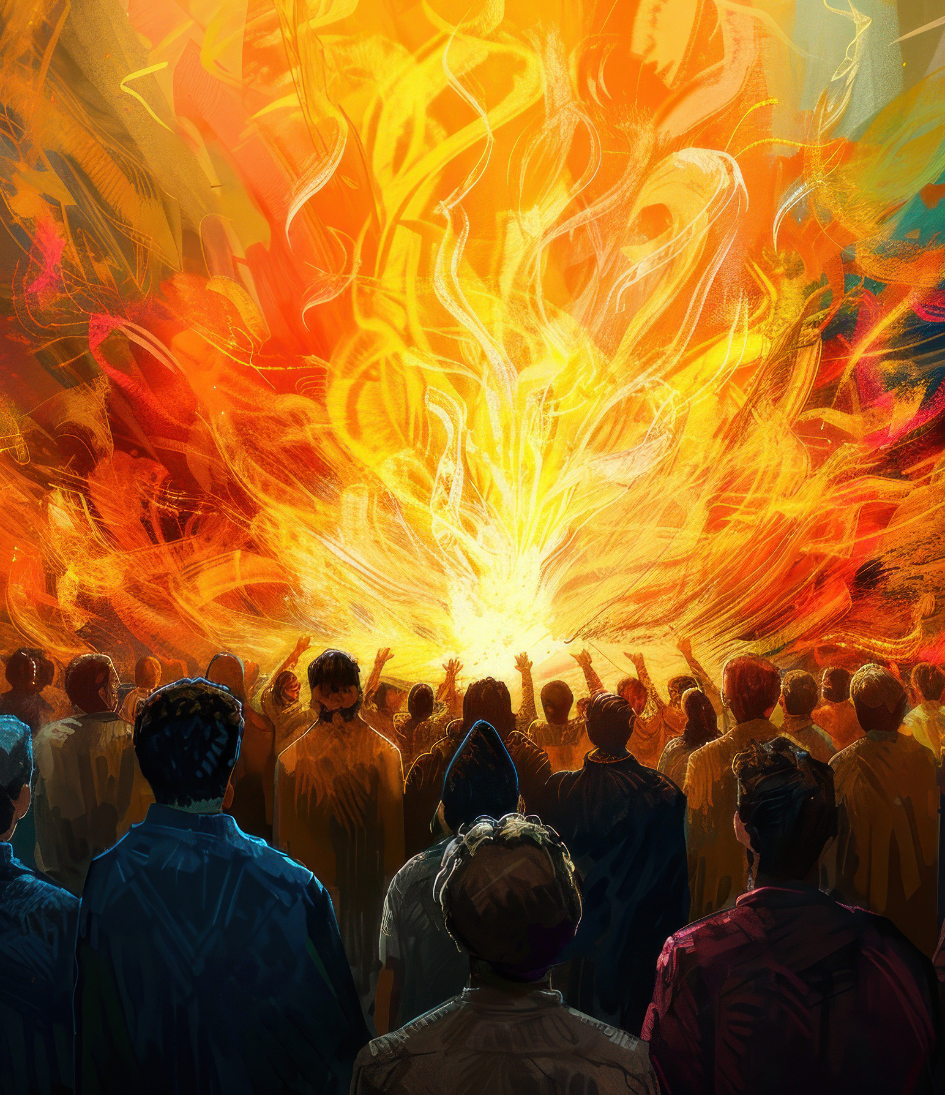
church name

xxx 2026
Time
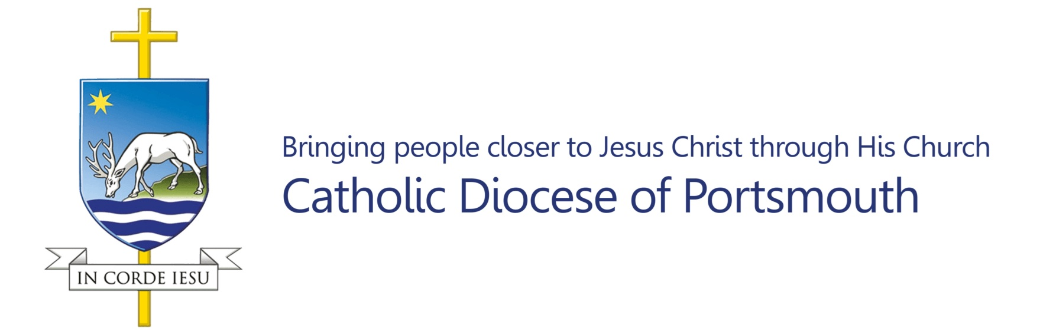
Acknowledgements

Excerpts from the English translation and chants of The Roman Missal © 2010 International Committee on English in the Liturgy Corporation. All rights reserved.

English translation of The Order of Confirmation © 2013, International Commission on English in the Liturgy Corporation. All rights reserved.

The English translation of the Lectionary for Mass © 2023 Catholic Bishop’s Conference of England and Wales and Bishops’ Conference of Scotland.

Copyright music and texts reproduced (and streamed online) under
One License
and
CCLI licence

Please list here the copyright music being used in the following format:
Christ, be our light © 1994 Bernadette Farrell. Published by OCP Publications.

Photography is not permitted during the Mass other than by the official photographer. At the end of the Mass there will be an opportunity to take photographs, this will include a group photo of all the children with the Bishop. If you do not consent to your child being in any photos (which may be published in the future) please ensure your child returns to you. If you do not wish your child to appear in any photographs, please make yourselves known to the Photographer before the Mass begins.

Please ensure all mobile phones are switched off before Mass begins.

Toilets may be found at XXX.

Please help us to keep a period of silence and reverence during the ten minutes before Mass and use the time to prepare yourself for Mass and pray for our candidates.

Gathering Chant

Please stand when the bell rings.

Entrance Hymn

INTRODUCTORY RITES

Sign of the Cross and Greeting

Bishop: In the name of the Father, and of the Son,
and of the Holy  Spirit,
All: Amen.
Bishop: Peace be with you.
All: And with your spirit.

Bishop Philip welcomes all present and introduces the celebration.

Penitential Act

Blessing and Sprinkling with Water and Salt

Holy Water is a symbol of cleansing and a reminder of our Baptism. The Bishop blesses water and salt and then passes through the church as he sprinkles the faithful with it. As we are sprinkled, we make the sign of the cross.

During the sprinkling, we sing:

Gloria (NB: please adjust text as necessary to reflect the Mass setting)

Glory to God in the highest,
and on earth peace to people of good will.
We praise you,
we bless you,
we adore you,
we glorify you,
we give you thanks for your great glory,
Lord God, heavenly King,
O God, almighty Father.
Lord Jesus Christ, Only Begotten Son,
Lord God, Lamb of God, Son of the Father,
you take away the sins of the world,
have mercy on us;
you take away the sins of the world,
receive our prayer;
you are seated at the right hand of the Father,
have mercy on us.
For you alone are the Holy One,
you alone are the Lord,
you alone are the Most High,
Jesus Christ,
with the Holy Spirit,
in the glory of God the Father.
Amen.

Collect

Bishop: Let us pray:

May the Paraclete who proceeds from you, we pray, O Lord, enlighten our minds and lead us into all truth, just as your Son has promised.
Who lives and reigns with you in the unity of the Holy Spirit, one God, for ever and ever.
All: Amen.

Please sit

LITURGY OF THE WORD

First Reading Acts 2:1-11

They were all filled with the Holy Spirit and began to speak.

When the day of Pentecost arrived,
the Apostles were all together in one place.
And suddenly there came from heaven a sound like a mighty
rushing wind, and it filled the entire house where they were sitting.
And divided tongues as of fire appeared to them
and rested on each one of them.
And they were all filled with the Holy Spirit
and began to speak in other tongues as the Spirit gave them utterance.
Now there were dwelling in Jerusalem Jews,
devout men from every nation under heaven.
And at this sound the multitude came together,
and they were bewildered, because each one was hearing them speak in his own language.
And they were amazed and astonished, saying,
‘Are not all these who are speaking Galileans?
And how is it that we hear, each of us in his own native language?
Parthians and Medes and Elamites
and residents of Mesopotamia,
Judea and Cappadocia, Pontus and Asia, Phrygia and Pamphylia,
Egypt and the parts of Libya belonging to Cyrene,
and visitors from Rome, both Jews and proselytes,
Cretans and Arabians —
we hear them telling in our own tongues
the mighty works of God.’

Reader: The Word of the Lord.
All: Thanks be to God.

Responsorial Psalm Psalm 104 (103)

Response: Send forth your spirit, O Lord,
and renew the face of the earth.

Bless the Lord, O my soul!
O Lord my God, how great you are!
How many are your works, O Lord!
The earth is full of your creatures. R/.

You take away their breath, they die,
returning to the dust from which they came.
You send forth your spirit, and they are created,
and you renew the face of the earth. R/.

May the glory of the Lord last for ever!
May the Lord rejoice in his works!
May my thoughts be pleasing to him.
I will rejoice in the Lord. R/.

Second Reading 1 Corinthians 12:3-7, 12-13

In one Spirit we were all baptised into one body.

Brothers and Sisters: No one can say ‘Jesus is Lord’ except in the Holy Spirit. Now there are varieties of gifts, but the same Spirit; and there are varieties of service, but the same Lord; and there are varieties of activities, but it is the same God who empowers them all in everyone.
To each is given the manifestation of the Spirit for the common good.
For just as the body is one and has many members, and all the members of the body, though many, are one body, so it is with Christ.
For in one Spirit, we were all baptised into one body — Jews or Greeks, slaves or free — and all were made to drink of one Spirit.

Reader: The Word of the Lord.
All: Thanks be to God.

Please Stand

Gospel Acclamation

Alleluia, Alleluia!
Come, Holy Spirit, fill the hearts of your faithful,
and kindle in them the fire of your love. Alleluia!
Gospel John 20:19-23

As the Father has sent me, even so I am sending you. Receive the Holy Spirit.

Deacon: The Lord be with you.
All: And with your spirit.
Deacon: A reading from the holy Gospel according to John.
All: Glory to you, O Lord.

On the evening of that day, the first day of the week, the doors being locked where the disciples were for fear of the Jews, Jesus came and stood among them and said to them, ‘Peace be with you.’
When he had said this, he showed them his hands and his side.
Then the disciples were glad when they saw the Lord.
Jesus said to them again, ‘Peace be with you.
As the Father has sent me, even so I am sending you.’
And when he had said this, he breathed on them and said to them, ‘Receive the Holy Spirit. If you forgive the sins of any, they are forgiven them; if you withhold forgiveness from any, it is withheld.’

Deacon: The Gospel of the Lord.
All: Praise to you, Lord Jesus Christ.

Please remain standing

At the conclusion of the proclamation of the Gospel, the Deacon takes the Book of the Gospels to Bishop Philip for him to venerate.
The Bishop will then bless the people with the Book of the Gospels.

Please then sit

Presentation of the Candidates

A catechist or the Co-ordinating Pastor will now ask the candidates to stand and will present the candidates to the Bishop:

Would the candidates for Confirmation please stand.

The candidates stand and remain in their places.

Most Reverend Father, on behalf of the [insert name of Pastoral Area/s] Pastoral Area I present to you these Candidates for the Sacrament of Confirmation.

Bishop Philip will greet the candidates and then invite them to sit.

Homily
RITE OF CONFIRMATION

Renewal of Baptismal Promises

The candidates stand and remain in their places for the renewal of baptismal promises.

Bishop: Do you renounce Satan, and all his works and empty promises?
Candidates: I do.

Bishop: Do you believe in God, the Father almighty, Creator of heaven and earth?
Candidates: I do.

Bishop: Do you believe in Jesus Christ, his only Son, our Lord, who was born of the Virgin Mary, suffered death and was buried, rose again from the dead and is seated at the right hand of the Father?
Candidates: I do.

Bishop: Do you believe in the Holy Spirit, the Lord, the giver of life, who today through the Sacrament of Confirmation is given to you in a special way just as he was given to the Apostles on the day of Pentecost?
Candidates: I do.

Bishop: Do you believe in the holy Catholic Church, the communion of saints, the forgiveness of sins, the resurrection of the body, and life everlasting?
Candidates: I do.

Bishop: This is our faith. This is the faith of the Church. We are proud to profess it in Christ Jesus our Lord.
All: Amen.

Laying on of Hands

The candidates come forward, under the direction of the stewards, along the sanctuary steps and stand facing the bishop for the Laying on of hands. Joined by the concelebrating priests, Bishop Philip, facing the people prays silently and all pray in silence for a while as the Bishop and priests extend their hands over the candidates.

Bishop: Almighty God, Father of our Lord Jesus Christ, who brought these your servants to new birth by water and the Holy Spirit, freeing them from sin: send upon them, O Lord, the Holy Spirit, the Paraclete; give them the spirit of wisdom and understanding, the spirit of counsel and fortitude, the spirit of knowledge and piety; fill them with the spirit of the fear of the Lord. Through Christ our Lord.
All: Amen.

Anointing with Sacred Chrism
Under the direction of the stewards, the candidates come forward,
with their sponsors, along the sanctuary steps and stand facing the altar.
Bishop Philip goes to each candidate in turn, accompanied by the deacons.

Each Sponsor shows the name card clearly to the Bishop, then hands it to the Deacon or Priest assisting the Bishop. The Sponsor places their right hand on the candidate’s right shoulder. Bishop Philip makes the sign of the cross on the candidate’s forehead with the oil of Chrism saying:

Bishop: N., be sealed with the gift of the Holy Spirit.
Candidate: Amen.
Bishop: Peace be with you.
Candidate: And with your spirit.

During which we sing the following:

LITURGY OF THE EUCHARIST

Offertory Hymn

Please stand to be incensed by the Deacon.
Bishop: Pray, brothers and sisters, that my sacrifice and yours may be acceptable to God, the almighty Father.
All: May the Lord accept the sacrifice at your hands for the praise and glory of his name, for our good and the good of all his holy Church.

Prayer over the Offerings

Bishop: Accept the oblation of your family, we pray, O Lord, that those who have received the gift of the Holy Spirit may keep safe what they have received and come to eternal rewards. Through Christ our Lord.
All: Amen.

THE EUCHARISTIC PRAYER

Bishop: The Lord be with you.
All: And with your spirit.
Bishop: Lift up your hearts.
All: We lift them up to the Lord.
Bishop: Let us give thanks to the Lord our God.
All: It is right and just.

Preface of the Holy Spirit

Sanctus (NB: please adjust text as necessary to reflect the Mass setting)

Holy, Holy, Holy Lord God of hosts.
Heaven and earth are full of your glory.
Hosanna in the highest.
Blessed is he who comes in the name of the Lord.
Hosanna in the highest.

Please kneel

Eucharistic Prayer III

Memorial Acclamation (NB: please adjust text as necessary to reflect the Mass setting)

Bishop: The mystery of faith.
All: We proclaim your Death, O Lord,
and profess your Resurrection
until you come again.
Doxology

Bishop: Through him, and with him, and in him, O God,
almighty Father, in the unity of the Holy Spirit,
all glory and honour is yours, for ever and ever.
All: Amen.

THE COMMUNION RITE

Please stand

Bishop: At the Saviour’s command and formed
by divine teaching, we dare to say:

All: Our Father, who art in heaven, hallowed be thy name; thy kingdom come, thy will be done on earth as it is in heaven. Give us this day our daily bread, and forgive us our trespasses, as we forgive those who trespass against us; and lead us not into temptation but deliver us from evil.

Bishop: Deliver us, Lord, we pray, from every evil, graciously grant peace in our days, that, by the help of your mercy, we may be always free from sin and safe from all distress, as we await the blessed hope and the coming of our Saviour, Jesus Christ.

All: For the kingdom, the power and the glory are yours
now and for ever.

Bishop: Lord Jesus Christ, who said to your Apostles: Peace I leave you, my peace I give you, look not on our sins, but on the faith of your Church, and graciously grant her peace and unity in accordance with your will.
Who live and reign for ever and ever.

All: Amen.

Bishop: The peace of the Lord be with you always.

All: And with your Spirit.

Deacon: Let us offer each other the sign of peace.

All exchange the customary sign of peace
with those immediately around them.
Agnus Dei

(NB: please adjust text as necessary to reflect the Mass setting)
Lamb of God, you take away the sins of the world, have mercy on us.
Lamb of God, you take away the sins of the world, have mercy on us.
Lamb of God, you take away the sins of the world, grant us peace.

Please kneel

Bishop: Behold the Lamb of God, behold him who takes away the sins of the world. Blessed are those called to the supper of the Lamb.

All: Lord, I am not worthy that you should enter under my roof but only say the word and my soul shall be healed.

Communicants are reminded to make an Act of Reverence
before receiving Holy Communion and
to consume the Sacred Host immediately upon its reception.

Those not in full communion with the Catholic Church – and those not receiving Holy Communion – are invited to make an act of ‘Spiritual Communion’ (see prayer below). You may wish to complete this by going forward to receive a blessing from the priest or deacon. Please indicate that you wish to receive a blessing by crossing your arms over your chest.

Act of Spiritual Communion

My Jesus, I believe that you are present in this Holy Sacrament of the altar.
I love you above all things and I passionately desire to receive you into my soul. Since I cannot now receive you sacramentally, come spiritually into my soul so that I may unite myself wholly to you now and forever. Amen.

(Based on a prayer of St Alphonsus Liguori)

Communion Hymns

Please stand

Prayer after Communion

Bishop: Pour on us, O Lord, the Spirit of your love and, in your kindness, make those you have nourished by this one heavenly Bread one in mind and heart.
Through Christ our Lord.
All: Amen.

CONCLUDING RITE

Bishop: The Lord be with you.
All: And with your spirit.
Bishop: Blessed be the name of the Lord.
All: Now and forever.
Bishop: Our help is in the name of the Lord.
All: Who made heaven and earth.
Bishop: May almighty God bless you,
the Father,  and the Son,  and the Holy  Spirit.
All: Amen.
Deacon: Go and announce the Gospel of the Lord.
All: Thanks be to God.

Recessional Hymn

At the end of Mass Bishop Philip will return to the front of the sanctuary for a group photograph with the newly confirmed who are asked to assemble there following the conclusion of the recessional hymn.
Please allow the official photographer to take a photograph first.

Please pray for our Candidates

INSERT NAMES

